# **CHAPTER 1**

# **INTRODUCTION**

## In an era where convenience and efficiency are paramount, the LPG (Liquefied Petroleum Gas) gas monitoring and automatic booking project emerge as a timely solution to address the challenges faced by households in managing their gas supply. LPG serves as a cornerstone energy source for cooking, heating, and various domestic applications worldwide. However, the traditional methods of monitoring gas levels and arranging refills often prove cumbersome and unreliable. The introduction of this project represents a paradigm shift in how consumers interact with their LPG supply, promising to revolutionize the way households manage their gas consumption.At its core, the LPG gas monitoring and automatic booking project leverage state-of-the-art IoT (Internet of Things) technology to provide real-time insights into gas levels within household cylinders. Gone are the days of manual checks or guesswork; with this system, consumers can effortlessly track their gas usage via a user-friendly mobile application or web interface. By offering continuous visibility into gas levels, the project empowers users to make informed decisions about their consumption habits, thereby optimizing efficiency and minimizing waste.

However, the true innovation of the project lies in its automatic booking feature. By analyzing usage patterns and gas levels in real-time, the system intelligently triggers refill requests when supplies approach predetermined thresholds. This seamless integration of monitoring and booking eliminates the need for manual intervention, saving consumers valuable time and ensuring a steady supply of gas. Moreover, the project's predictive capabilities help prevent unexpected shortages, providing households with unparalleled peace of mind.

Beyond convenience, the project also prioritizes safety. Through continuous monitoring, the system can detect and alert users to potential gas leaks or irregularities promptly. Early warnings enable swift action, mitigating risks and ensuring the well-being of households. By enhancing safety measures and facilitating proactive management of gas supply, the project not only simplifies daily routines but also safeguards lives and property.

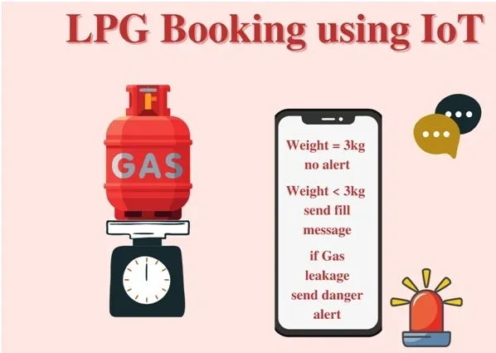

Fig 1.1: LPG gas monitoring and automatic booking system

## **1.1: Problem Statement:**

Despite being a crucial energy source for countless households worldwide, managing LPG (Liquefied Petroleum Gas) supply efficiently poses significant challenges. Traditional methods of monitoring gas levels and arranging refills are often manual, time-consuming, and prone to errors, leading to inconvenience and potential safety risks for consumers. Statistical data highlights the extent of these challenges and underscores the urgent need for a solution that offers automated monitoring and booking capabilities.

* According to the World LPG Association (WLPGA), the global demand for LPG is steadily increasing, driven by its versatility, efficiency, and environmental benefits. However, this growing demand exacerbates the challenges associated with managing LPG supply, including monitoring gas levels and arranging timely refills.
* A survey conducted by a leading consumer advocacy group revealed that a significant percentage of LPG consumers experience difficulties in accurately estimating gas levels in their cylinders. This uncertainty often leads to unexpected gas shortages, inconvenience, and frustration among consumers.
* Data from LPG distributors indicates that a substantial portion of refill requests are initiated reactively, after consumers have already experienced gas shortages or run out of supply. This reactive approach not only disrupts household routines but also places additional strain on distributors' resources and logistics.
* Research conducted by safety organizations highlights the risks associated with manual handling and transportation of LPG cylinders, including the potential for leaks, spills, and accidents. Inefficient monitoring and booking processes contribute to these risks by prolonging the time between refill requests and increasing the likelihood of emergencies.

Based on these statistical proofs, it is evident that the current methods of managing LPG supply are inadequate and pose significant challenges for consumers and distributors alike. The implementation of a solution that offers automated gas monitoring and booking capabilities is crucial to address these challenges, improve efficiency, and enhance safety in LPG usage.

## **1.2: Problem Scope**:

The problem scope for the LPG Gas Monitoring system and Automatic Booking are:

**Pressure Sensor Selection and Integration:**

* + Identify suitable pressure sensors capable of accurately measuring gas levels within LPG cylinders.
  + Ensure compatibility with different types and sizes of cylinders commonly used in home settings.
  + Integrate pressure sensors into the existing gas distribution system while minimizing disruption to household operations.
* **Leak Detection Algorithm Development:**
  + Developing algorithms to analyze pressure sensor data and detect potential gas leaks or abnormalities.
  + Define thresholds and criteria for identifying abnormal pressure fluctuations indicative of leaks.
  + Implement real-time monitoring and alerting mechanisms to notify homeowners of detected leaks promptly.
* **System Architecture and Integration:**
  + Design an overarching system architecture that seamlessly integrates pressure sensors, leak detection algorithms, and the existing gas distribution infrastructure.
  + Ensure interoperability and compatibility between different components to facilitate data exchange and communication.
  + Implement data logging and storage mechanisms to maintain a record of gas storage levels and leak detection events for analysis and auditing purposes.
* **Mobile Application Development:**
  + Develop a user-friendly mobile application interface for homeowners to access and manage their gas supply.
  + Implement features for scheduling gas cylinder refills, viewing gas storage levels, and receiving alerts for detected leaks.
  + Ensure cross-platform compatibility and usability across different mobile devices and operating systems.
* **Automation of Gas Cylinder Booking:**
  + Integrate the mobile application with gas suppliers' booking systems to enable automated scheduling of cylinder refills.
  + Establish secure communication channels and authentication mechanisms to ensure the integrity and confidentiality of booking transactions.
  + Implement logic for optimizing refill scheduling based on gas usage patterns, delivery availability, and homeowner preferences.
* **Safety and Regulatory Compliance:**
  + Conduct risk assessments to identify potential safety hazards associated with the gas distribution system and leak detection mechanisms.
  + Ensure compliance with relevant safety standards, regulations, and industry best practices governing the installation and operation of gas management systems.
  + Implement safeguards and fail-safe mechanisms to mitigate risks associated with gas supply malfunctions, leaks, and other safety hazards.
* **Scalability and Future Expansion:**
  + Design the system with scalability in mind to accommodate future growth in user demand and technological advancements.
  + Develop strategies for upgrading and expanding the system to support additional functionalities, such as integrating with smart home automation systems or incorporating new types of sensors.
  + Plan for regular maintenance and updates to ensure the long-term reliability and performance of the gas monitoring and automatic booking system.

## **1.3: Advantages of using LPG Gas Monitoring and Automatic booking.**

* **Enhanced Safety:**
  + Continuous monitoring detects gas leaks or abnormalities promptly, minimizing safety hazards.
  + Early detection of potential issues allows for timely intervention to prevent accidents.
* **Convenience:**
  + Automation eliminates the need for manual booking, saving time and effort for homeowners.
  + Booking refills through a mobile application offers convenience from anywhere, anytime.
* **Efficiency:**
  + Real-time monitoring optimizes gas usage, reducing waste and maximizing efficiency.
  + Insights into usage patterns enable informed decisions to minimize consumption and costs.
* **Peace of Mind:**
  + Automated features provide assurance that gas supply is managed efficiently and safely.
  + Timely alerts for leaks or abnormal fluctuations ensure proactive response to potential hazards.
* **Accessibility:**
  + Mobile application interface allows easy access and management of gas supply on-the-go.
  + Homeowners can check gas levels, schedule refills, and receive alerts conveniently from their smartphone or tablet.
* **Reduced Downtime:**
  + Timely refills prevent unexpected shortages and downtime in gas supply.
  + Uninterrupted access to essential gas ensures continuity in daily routines and activities.
* **Environmental Benefits:**
  + Optimization of gas usage and reduced waste contribute to environmental sustainability.
  + Efficient management practices help conserve resources and minimize carbon emissions.

## **1.4 Proposed Solution:**

The proposed solution for the project involves implementing a comprehensive Gas Management System that addresses the monitoring of gas storage, detection of potential leaks, and automation for booking gas cylinders. The system utilizes pressure sensors for real-time monitoring of gas storage levels and employs algorithms to detect abnormalities indicative of leaks. Additionally, automation features are integrated into a mobile application, allowing homeowners to conveniently schedule gas cylinder refills.

* **Pressure Sensor Monitoring:** Pressure sensors are installed within gas storage systems to continuously monitor gas levels. These sensors provide real-time data on gas storage levels, enabling homeowners to track usage and detect any anomalies.
* **Leak Detection Algorithms:** Advanced algorithms analyze pressure sensor data to detect potential gas leaks or abnormalities. These algorithms are designed to identify abnormal fluctuations in gas pressure, indicative of leaks, and trigger alerts for prompt action.
* **Mobile Application Interface:** A user-friendly mobile application interface allows homeowners to access and manage their gas supply conveniently. Through the application, homeowners can schedule gas cylinder refills, monitor gas storage levels, and receive alerts for detected leaks.
* **Automation for Gas Cylinder Booking:** Automation features enable homeowners to schedule gas cylinder refills seamlessly through the mobile application. The system automatically generates refill requests based on gas usage patterns and availability, eliminating the need for manual intervention.

## **1.5 Aim and Objectives**

## **Aim:**

* The aim of the LPG Gas Monitoring System and Automatic Booking project is to revolutionize the management of household gas supply by implementing an integrated solution that ensures efficient distribution, enhances safety, and maximizes convenience for homeowners. At its core, the project seeks to address the critical need for a reliable and user-friendly gas management system that not only monitors gas storage effectively but also automates the process of booking gas cylinder refills. By focusing on the integral pipeline distribution system, which is fundamental to all home gas management systems, the project aims to ensure the seamless delivery of essential gases and vacuum precisely where they are needed within households. Central to this aim is the provision of a properly designed, installed, and maintained distribution system, which is crucial for safeguarding the safety and security of residents. The project recognizes the significant risks posed by mishaps involving gas supply malfunctions or leaks and aims to mitigate these hazards through the implementation of advanced monitoring technologies. Leveraging pressure sensors, the system will continuously monitor gas storage levels and promptly detect any potential leaks, enabling homeowners to take proactive measures to address safety concerns. Additionally, the integration of automation for booking gas cylinders through a mobile application represents a significant advancement in convenience and efficiency. This feature will empower homeowners to manage their gas supply effortlessly, from scheduling refills to receiving timely alerts and notifications, all through a user-friendly mobile interface. Ultimately, the aim of the project is to optimize gas usage, enhance safety measures, and provide homeowners with peace of mind, knowing that their gas supply is being managed efficiently and securely.

## **Objectives:**

* The objectives of implementing LPG gas monitoring and automatic booking for homes are :
* **Implement Gas Storage Monitoring:**
  + Install pressure sensors to monitor gas storage levels accurately.
  + Develop a system to collect and analyze data from pressure sensors in real-time.
* **Develop Leak Detection Mechanisms:**
  + Design algorithms to detect potential gas leaks based on pressure sensor data.
  + Implement automated alert systems to notify homeowners of detected leaks promptly.
* **Integrate Mobile Application for Booking:**
  + Develop a user-friendly mobile application interface for homeowners to schedule gas cylinder refills.
  + Establish secure communication channels between the mobile application and gas suppliers' booking systems.
* **Ensure Compatibility and Scalability:**
  + Ensure interoperability with existing home gas management systems and infrastructure.
  + Design the system to be scalable, allowing for future upgrades and expansions.
* **Enhance Safety Measures:**
  + Conduct risk assessments to identify potential safety hazards associated with the gas distribution system.
  + Implement safety protocols and fail-safe mechanisms to mitigate risks and ensure the safety of residents.
* **Optimize Gas Usage and Efficiency:**
  + Provide insights into gas usage patterns to help homeowners optimize consumption habits.
  + Develop features to minimize waste and maximize efficiency in gas usage.
* **Ensure Reliability and Maintenance:**
  + Design the system to be reliable and easy to maintain, with minimal downtime.
  + Provide documentation and support for homeowners to troubleshoot and resolve any issues that may arise.

# **CHAPTER 2**

# **Literature Survey**

A comprehensive literature survey on LPG gas monitoring and automatic booking, based on published papers, reveals a rich landscape of research efforts aimed at improving the efficiency, safety, and convenience of managing household gas supply. Delving into various disciplines including engineering, computer science, and environmental science, these studies explore a range of technologies, methodologies, and applications. One significant focus area lies in sensor technologies, with researchers developing and evaluating different types of sensors, such as pressure sensors, ultrasonic sensors, and gas detectors, for monitoring LPG gas storage levels and detecting potential leaks. These studies investigate factors like sensor accuracy, reliability, and responsiveness in real-world conditions, including considerations like placement and calibration methods. Moreover, the literature encompasses the application of data analytics and machine learning algorithms for analyzing sensor data to identify anomalies indicative of gas leaks. Papers delve into algorithmic approaches such as anomaly detection and pattern recognition, striving to achieve high accuracy and minimal false positives. Furthermore, there's substantial research into the development, usability, and acceptance of mobile applications for automating the booking of LPG gas cylinder refills. This includes investigations into user interface design principles, accessibility, and security aspects of mobile-based booking systems. Additionally, integration of sensor networks and IoT platforms is explored to enable comprehensive gas monitoring and management, combining sensor data acquisition, cloud-based analytics, and mobile application interfaces for real-time monitoring and automated booking functionalities. Safety standards, regulations, and compliance requirements governing gas monitoring and distribution systems are also discussed, emphasizing the importance of adherence to ensure safety, reliability, and legality. Finally, the literature includes valuable insights from case studies and field trials, documenting the deployment and evaluation of LPG gas monitoring and automatic booking systems in real-world settings, providing empirical data and user feedback on practical effectiveness and user acceptance. Overall, the literature survey presents a multifaceted exploration of LPG gas monitoring and automatic booking, showcasing technological advancements, research challenges, and avenues for future innovation in this critical domain.

* In the realm of LPG gas monitoring and automatic booking, various dimensions beyond technical functionalities are explored to offer a holistic understanding and facilitate effective implementation. Studies delve into the role of gas monitoring systems in promoting energy efficiency and sustainability by optimizing gas usage through real-time monitoring and automated booking, thus contributing to reducing energy waste and minimizing environmental impact. Additionally, research efforts extend to understanding user behavior and adoption patterns concerning these systems, including user preferences, motivations, and barriers to adoption, along with strategies for enhancing user engagement and acceptance.
* Moreover, the sensitive nature of personal and consumption data collected by gas monitoring systems prompts investigations into data security and privacy concerns, leading to discussions on encryption techniques, data anonymization methods, and compliance with privacy regulations. Furthermore, studies address the challenges and opportunities associated with interoperability and integration of gas monitoring systems with other smart home devices and platforms, emphasizing standardization efforts, communication protocols, and compatibility with existing home automation ecosystems. Cost-benefit analyses are conducted to evaluate the economic feasibility and return on investment of implementing these systems, considering factors such as upfront costs, ongoing maintenance expenses, and potential savings from improved efficiency. Social and cultural factors are also taken into account, recognizing how cultural norms, socioeconomic status, and household dynamics may influence adoption and use. Finally, research delves into the regulatory and policy implications of deploying gas monitoring and automatic booking systems, encompassing considerations related to energy policy, consumer protection, and public safety, and discussing regulatory frameworks, industry standards, and government initiatives aimed at promoting the adoption of smart energy technologies. Integrating these diverse perspectives ensures a comprehensive approach to addressing the multifaceted challenges and opportunities in the domain of LPG gas monitoring and automatic booking.

# **CHAPTER 3**

# **Methodology**

* In the methodology for implementing LPG gas monitoring and automatic booking using NodeMCU, MQ135 gas sensor, load cell, temperature sensor, and GSM module, several steps are involved to ensure efficient and safe gas management within households. Firstly, NodeMCU, a versatile microcontroller board, is utilized as the central processing unit to interface with various sensors and modules. The MQ135 gas sensor is deployed to detect LPG gas leaks by measuring air quality and detecting the presence of harmful gases such as methane and carbon dioxide. Additionally, a load cell is employed to monitor gas cylinder weight, providing real-time data on gas consumption and remaining gas volume.
* Furthermore, a temperature sensor is integrated to monitor ambient temperature, ensuring optimal storage conditions for gas cylinders and detecting any temperature anomalies that may indicate potential safety hazards. The NodeMCU collects data from these sensors and processes it to identify gas leaks, monitor gas consumption, and ensure the integrity of the gas storage system.
* Additionally, a GSM module is incorporated into the system to enable remote communication and automatic booking of gas cylinders. The GSM module allows the NodeMCU to send SMS alerts to homeowners in case of gas leaks or abnormal conditions detected by the sensors. Moreover, it facilitates communication with a mobile application, through which homeowners can remotely monitor gas levels, receive alerts, and place orders for gas cylinder refills.
* The mobile application serves as a user-friendly interface for homeowners to manage their gas supply efficiently. It provides real-time updates on gas levels, temperature, and potential gas leaks detected by the sensors. Users can also initiate automatic booking of gas cylinder refills directly from the mobile application, eliminating the need for manual intervention and ensuring a seamless and convenient gas management experience.
* Overall, the methodology leverages NodeMCU, MQ135 gas sensor, load cell, temperature sensor, and GSM module to implement a comprehensive LPG gas monitoring and automatic booking system. By continuously monitoring gas storage conditions, detecting leaks, and facilitating remote communication and booking, the system ensures the safety, efficiency, and convenience of gas management within households.
* 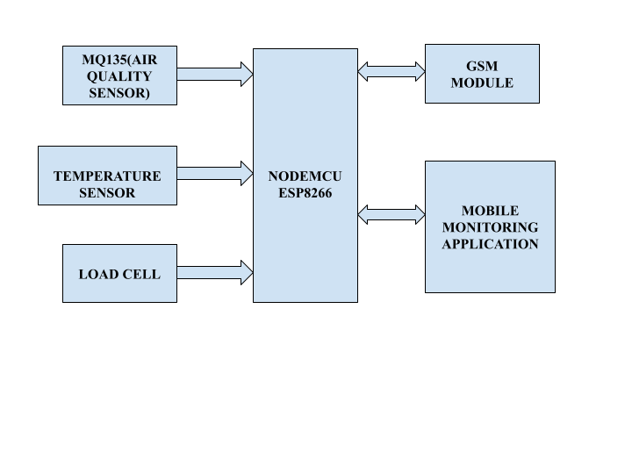
* Fig . 3.1. Block diagram for LPG Gas Monitoring and Automatic Booking System.

## **3.1 NodeMCU (ESP8266 )**

The NodeMCU ESP8266 is a powerful and versatile platform designed for Internet of Things (IoT) development. The ESP8266 is a cost-effective Wi-Fi microchip known for its capability to enable wireless communication in IoT applications. NodeMCU, on the other hand, is an open-source firmware and development kit that simplifies the process of prototyping and programming the ESP8266. With built-in Wi-Fi connectivity, the NodeMCU ESP8266 allows devices to connect to the internet wirelessly, making it suitable for a wide range of IoT projects. One notable feature is its support for the Lua scripting language, providing a high-level programming environment for developers. Additionally, it is compatible with the Arduino IDE, allowing those familiar with Arduino to use the NodeMCU platform. Equipped with General Purpose Input/Output (GPIO) pins, the ESP8266 facilitates interfacing with various electronic components, making it ideal for applications such as home automation and sensor networks. The NodeMCU ESP8266 has garnered significant community support, resulting in an extensive collection of libraries and documentation, making it a popular choice for rapid IoT prototyping and development.

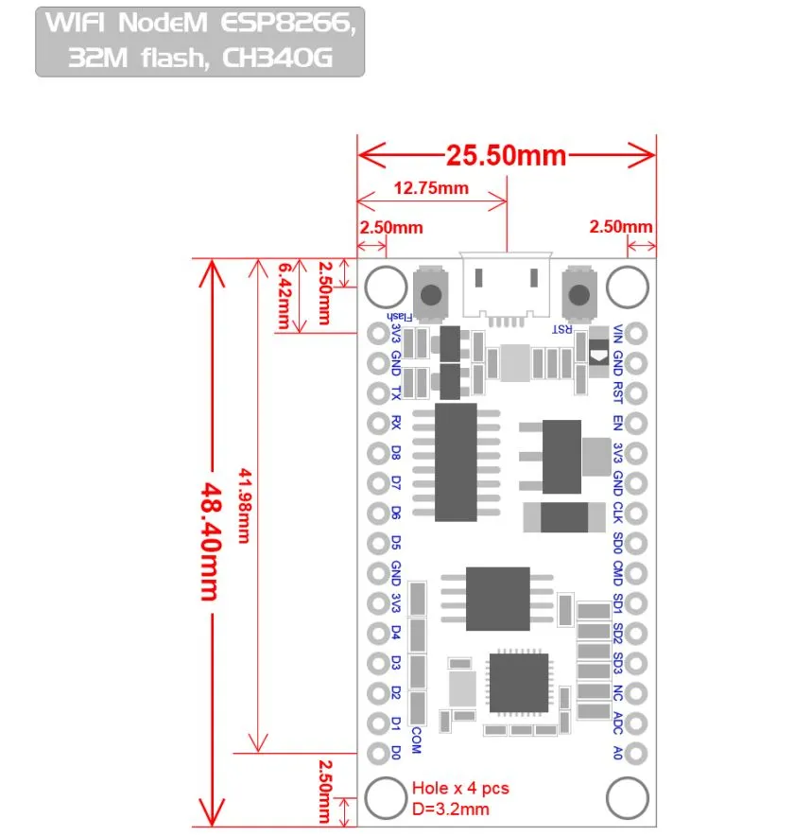

Figure 3.2 NodeMCU 2D View

**NodeMCU Specification:**

The NodeMCU development board is based on the ESP8266 microcontroller, and different versions of NodeMCU boards may have slight variations in specifications. As of my knowledge cutoff in January 2022, here are the general specifications for the NodeMCU ESP8266 development board:

**1. Microcontroller:** ESP8266 Wi-Fi microcontroller with 32-bit architecture.

**2. Processor:** Tensilica L106 32-bit microcontroller.

**3. Clock Frequency:** Typically operates at 80 MHz.

**4. Flash Memory:**

* Built-in Flash memory for program storage.
* Common configurations include 4MB or 16MB of Flash memory.

**5. RAM:** Typically equipped with 80 KB of RAM.

**6. Wireless Connectivity:**

* Integrated Wi-Fi (802.11 b/g/n) for wireless communication.
* Supports Station, SoftAP, and SoftAP + Station modes.

**7. GPIO Pins:** Multiple General Purpose Input/Output (GPIO) pins for interfacing with sensors, actuators, and other electronic components.

**8. Analog Pins:** Analog-to-digital converter (ADC) pins for reading analog sensor values.

**9. USB-to-Serial Converter:** Built-in USB-to-Serial converter for programming and debugging.

**10. Operating Voltage:** Typically operates at 3.3V (Note: It is crucial to connect external components accordingly to avoid damage).

**11. Programming Interface:** Programmable using the Arduino IDE, Lua scripting language, or other compatible frameworks.

**12. Voltage Regulator:** Onboard voltage regulator for stable operation.

**13. Reset Button:** Reset button for restarting the board.

**14. Dimensions:** Standard NodeMCU boards often have dimensions around 49mm x 24mm.

**15. Power Consumption:** Low power consumption, making it suitable for battery-operated applications.

**16. Community Support:** Active community support with extensive documentation and libraries.

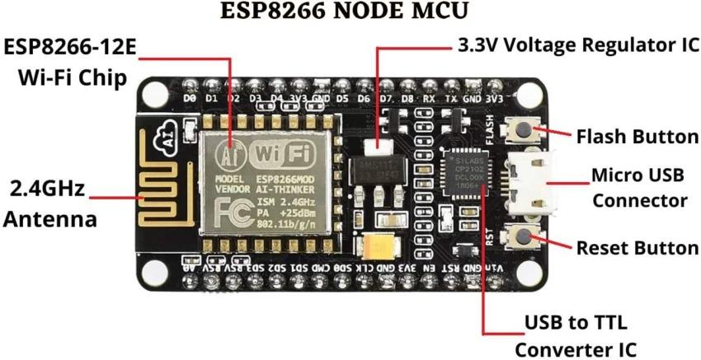

Figure 3.3: NodeMCU Parts

The NodeMCU ESP8266 development board typically has GPIO (General Purpose Input/Output) pins that can be used for various purposes, including interfacing with sensors, actuators, and other electronic components. Below is a common pinout configuration for the NodeMCU development board

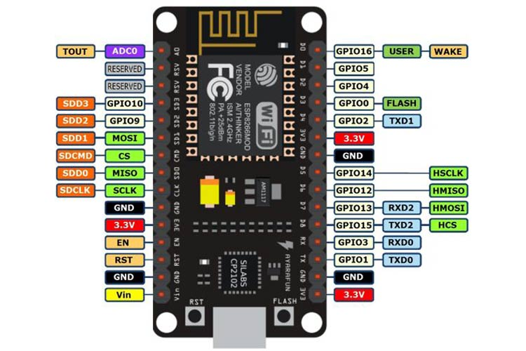

Figure 3.4: NodeMCU ESP8266 Pinout

ADC | A0 | GPIO16

EN | Enable | GPIO14

D0 | GPIO16 | GPIO12

D1 | GPIO5 | GPIO13

D2 | GPIO4 | GPIO15

D3 | GPIO0 | GPIO2

D4 | GPIO2 | GPIO9

D5 | GPIO14 | GPIO10

D6 | GPIO12 | GPIO3

D7 | GPIO13 | GPIO1

D8 | GPIO15 | TX (GPIO1)

D9 | GPIO3 (RX) | RX (GPIO3)

D10 | GPIO1 (TX) | D11 (MOSI)

D11 | MOSI | D12 (MISO)

D12 | MISO | D13 (SCK

**ADC**: Analog-to-Digital Converter pin for reading analog sensor values.

**EN** (Enable): Enable pin.

**D0-D8**: Digital GPIO pins.

**D9 (RX) and D10 (TX)**: Serial communication pins for programming and debugging.

**D11 (MOSI), D12 (MISO), D13 (SCK**): Pins used for SPI communication.

**D14 (SDA) and D15 (SCL)**: Pins used for I2C communication.

It's important to note that GPIO pins labeled as "D" (Digital) are typically used for general-purpose digital input/output. Additionally, GPIO pins labeled as "A" (Analog) can be used as analog inputs with the ADC. GPIO pins 6, 7, 8, 9, 10, and 11 have additional functions, so it's advised to refer to the specific NodeMCU documentation for detailed information on pin functionality and capabilities.

## **3.2 MQ-135 Gas sensor:**

The **MQ-135 Gas sensor** can detect gases like Ammonia (NH3), sulfur (S), Benzene (C6H6), CO2, and other harmful gases and smoke. Similar to other MQ series gas sensors, this sensor also has a digital and analog output pin. When the level of these gases go beyond a threshold limit in the air the digital pin goes high. This threshold value can be set by using the on-board potentiometer. The analog output pin, outputs an analog voltage which can be used to approximate the level of these gases in the atmosphere.

The MQ135 air quality sensor module operates at 5V and consumes around 150mA. It requires some preheating before it could actually give accurate results.

**Details of MQ135 Sensor**

The MQ135 is one of the popular gas sensors from the MQ series of sensors that are commonly used in air quality control equipment. It operates from 2.5V to 5.0V and can provide both digital and analog output. The pinouts and important components on an MQ135 Module is marked below

Note that all MQ sensors have to be powered up for a pre-heat duration for the sensor to warm up before it can start working. This preheat time is normally between 30 seconds to a couple of minutes. When you power up the module the power LED will turn on, leaving the module in this state till the pre-heat duration is completed.

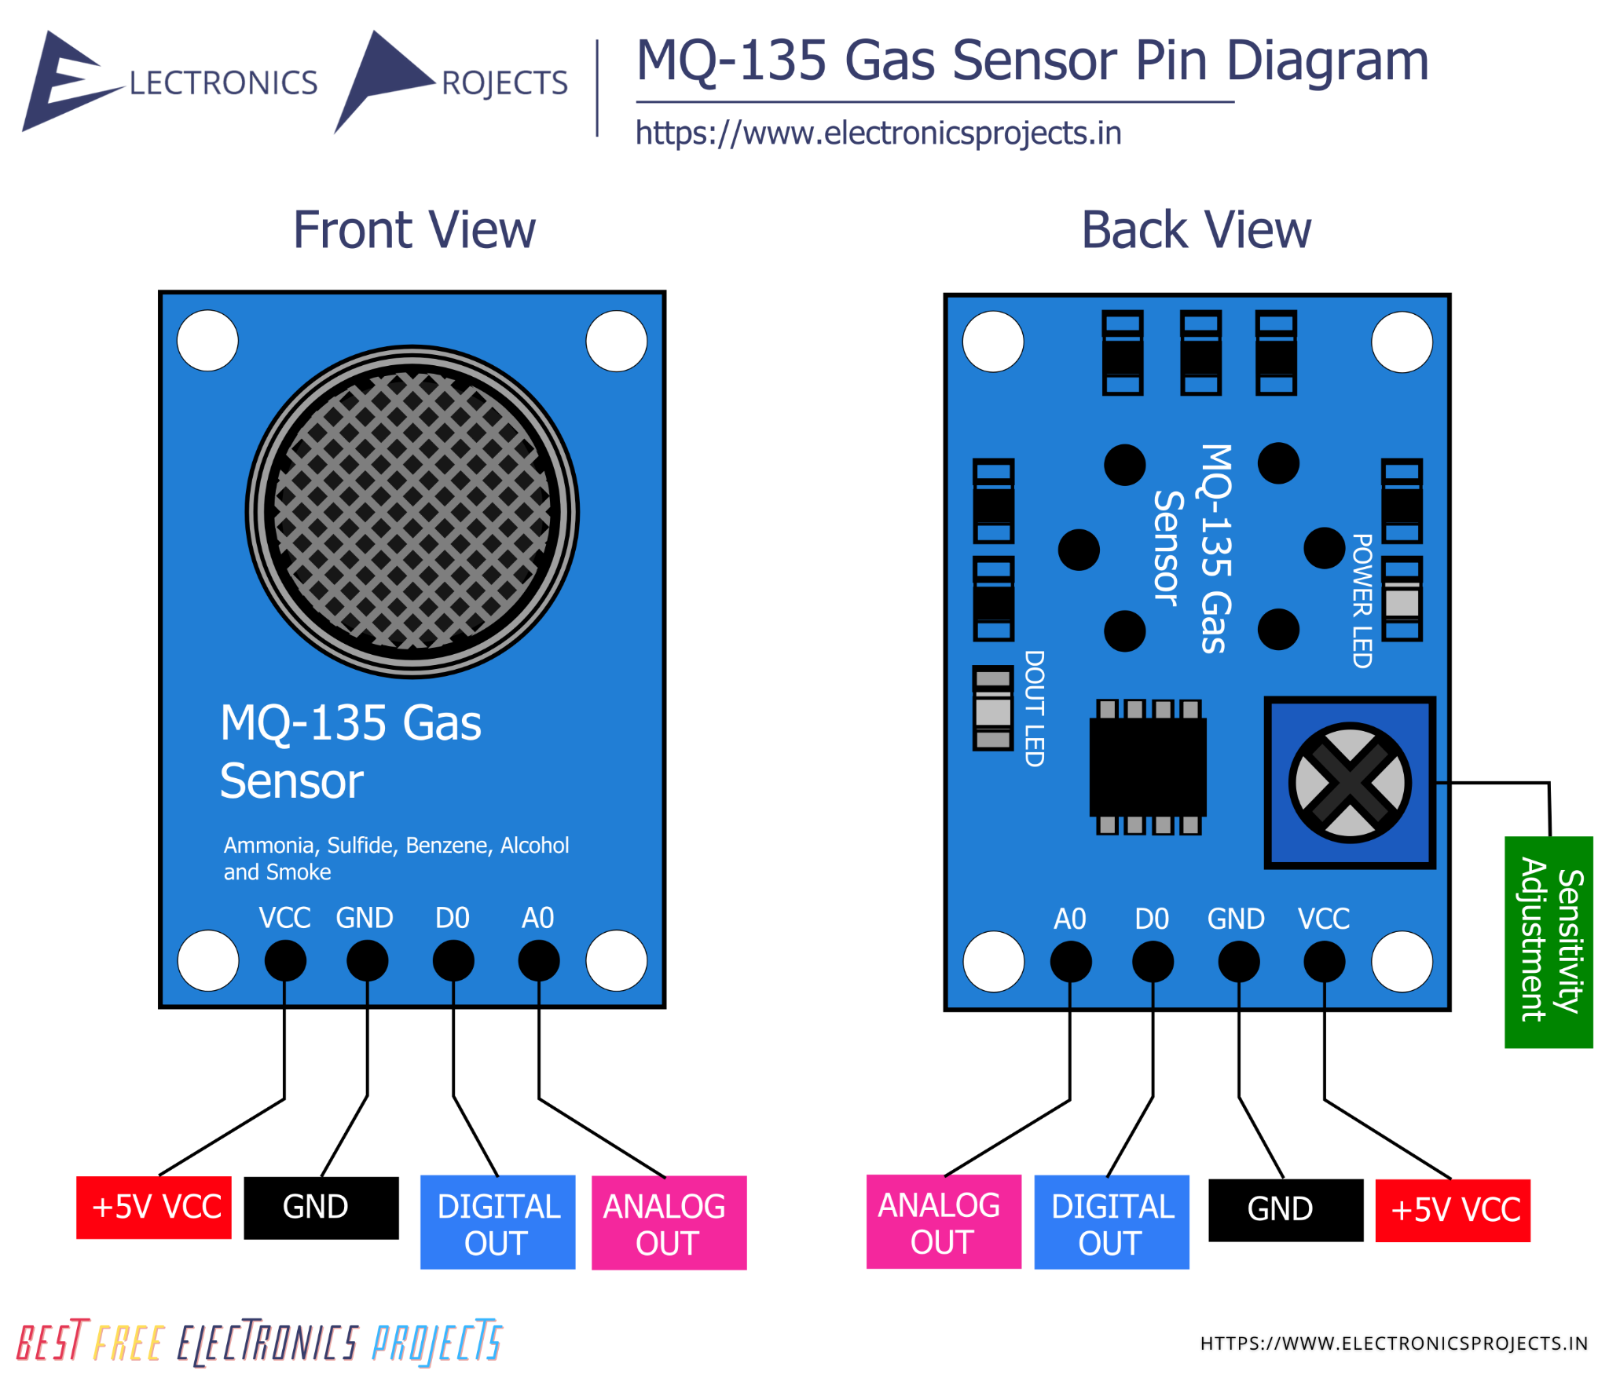

Figure 3.5: MQ135 Gas Sensor

**Technical Specifications of MQ135 Gas Sensor**

* Operating Voltage: 2.5V to 5.0V
* Power consumption: 150mA
* Detect/Measure: NH3, Nox, CO2, Alcohol, Benzene, Smoke
* Typical operating Voltage: 5V
* Digital Output: 0V to 5V (TTL Logic ) @ 5V Vcc
* Analog Output: 0-5V @ 5V Vcc

**Detect Harmful Gasses using Digital Pin:**

The digital output pin of the sensor can be used to detect harmful gasses in the environment. The sensitivity of the digital pin can be controlled by using the 10k potentiometer. If the gas is detected the indicator LED D0 will turn on and the digital pin will go from logic high to logic low (0V). The LM393 Op-Amp Comparator IC is used to compare the actual gas value with the value set using the potentiometer. If the actual gas value increases than the set value then the digital output pin gets low.

Because of the onboard LM393 comparator IC the MQ135 Gas sensor module can also be used without the need of an external microcontroller. Simply power up the module and set the sensitivity of the digital pin using the potentiometer, then when the module detects the gas the digital pin will go low. This digital pin can directly be used to drive a buzzer or LED with the help of simple transistors.

**Measure PPM Value using Analog Pin:**

The Analog output pin of the sensor can be used to measure the PPM value of the required gas. To do this we need to use an external microcontroller like Arduino. The microcontroller will measure the value of analog voltage and perform some calculations to find the value of Rs/Ro where Rs is the sensor resistance when gas is present and Ro is sensor resistance at clean air. Once we find this ratio of Rs/Ro we can use it to calculate the PPM value of required gas using the graph below which is taken from the datasheet of MQ135 Sensor.

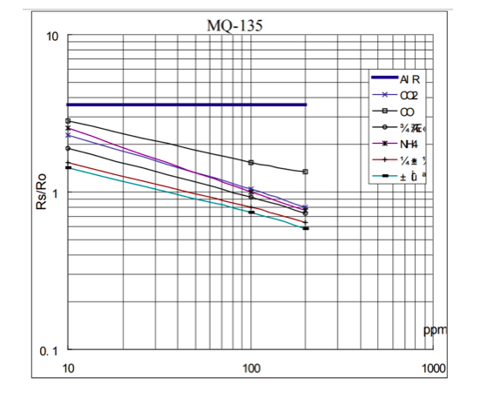

Figure 3.6: MQ135 Measurement of Smoke values

If you are just detecting the gas and not measuring the PPM then the module need not be calibrated or pre-heated and hence it is extremely simple to use. You can find these MQ Gas sensors commonly used in Gas/Smoke detectors and Air Quality Monitors. The dimensions of the MQ135 Gas sensor module is given below

**Further Resources:**

* [Datasheet of MQ135](https://components101.com/sites/default/files/component_datasheet/MQ135%2520Datasheet.pdf)
* [MQ-135 Arduino Library](https://github.com/GeorgK/MQ135)

# **3.3 Load Cell**

A load cell is an electro-mechanical sensor used to measure force or weight. It has a simple yet effective design which relies upon the well-known transference between an applied force, material deformation and the flow of electricity. They are incredibly versatile devices that offer accurate and robust performance across a diverse range of applications. It’s no surprise that they have become essential to many industrial and commercial processes, from automating car manufacturing to weighing your shopping at the checkout. As technology explodes forward, many new and exciting applications are emerging that also stand to benefit from using load cells. New advances in robotics, haptics and medical prostheses, to name a few, all need effective ways to measure forces and weights. New types of load cells are continuously being designed to meet the needs of this ever-changing market.

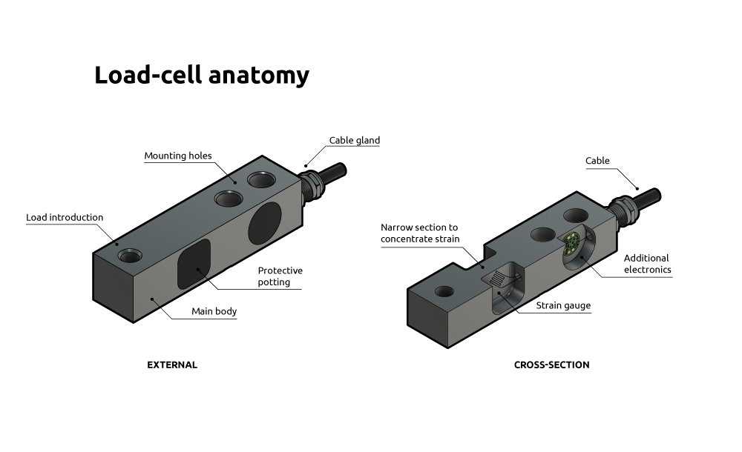

* Fig 3.7 Load cell
* A typical load cell consists of two parts: the main body and an attached electrical circuit. The main body is what bears the weight or force and accounts for most of the load cell’s size. Typically, it is made from high-grade steel or aluminium, which ensures mechanical reliability, and predictable and uniform strain distribution.
* The electrical circuit is housed within the load cell, tightly bonded to the main body. The circuit includes strain-gauges which are specialized parts of the circuit designed to sense the deformations of the main body.
* These strain-gauges consist of thin, electrically conductive wire or foil arranged in a tight zig-zag pattern. This pattern makes them sensitive to stretch and compression along their length, but insensitive across their width. As such, they can be precisely positioned to sense forces that run along particular axes. For example, shear beam load cells have their strain gauges positioned at a 45-degree angle to the loading axis, so as to maximize the detection of the shear strain running through the load cell.

## 

## **3.4 Temperature and Humidity Sensor:**

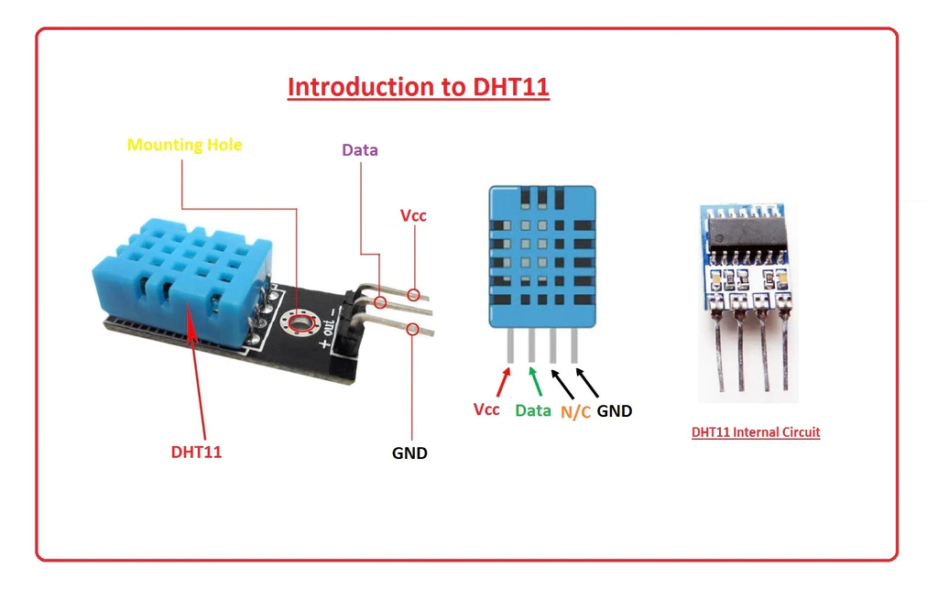

Figure 3.8 DHT 11 sensor

**Temperature and Humidity Sensor**

A temperature sensor is a device that measures the temperature of its surroundings or a specific object and converts that temperature into an electrical signal. Temperature sensors are used in a wide range of applications, including industrial processes, environmental monitoring, consumer electronics, medical devices, and more.

**Features of Temperature Sensors:**

1. **Accuracy:** Temperature sensors should provide accurate readings to ensure precise temperature measurements.
2. **Range:** They should be able to measure temperatures within a specific range, which can vary from sensor to sensor.
3. **Response Time:** The time it takes for a sensor to detect and report a change in temperature.
4. Resolution: The smallest temperature difference that a sensor can detect and report.
5. **Stability:** Consistency of readings over time and in various conditions.
6. **Calibration:** Some temperature sensors might need periodic calibration to maintain accuracy.
7. **Output Type:** Temperature sensors can provide analog or digital outputs, depending on the type of sensor.

**Sensitivity Adjustments:**

Sensitivity adjustment in a temperature sensor refers to the ability to fine-tune the sensor's response to temperature changes. Some sensors offer the option to adjust sensitivity to match specific requirements or to compensate for external factors that might affect accuracy.

**Principle of Temperature Measurement:**

Different types of temperature sensors work based on various principles. Some common principles include

**Thermocouples:** These sensors use the Seebeck effect, where two different metals connected at two junctions produce a voltage proportional to the temperature difference between the junctions. The voltage generated is used to determine the temperature.

**RTDs (Resistance Temperature Detectors):** RTDs are based on the principle that the electrical resistance of a material changes with temperature. They use materials with a predictable resistance-temperature relationship, such as platinum, to measure temperature.

**Thermistors:** Thermistors are temperature-sensitive resistors that have a resistance that changes significantly with temperature. They can be either Negative Temperature Coefficient (NTC) or Positive Temperature Coefficient (PTC) thermistors.

**Infrared Sensors:** These sensors detect the infrared radiation emitted by an object to calculate its temperature. They are particularly useful for non-contact temperature measurement.

**Bimetallic Strips:** Bimetallic strips consist of two different metals with different coefficients of thermal expansion bonded together. As the temperature changes, the strip bends due to the differential expansion, and this bending can be used to measure temperature.

**Semiconductor Temperature Sensors:** These sensors use the temperature-dependent properties of semiconductors, such as diodes or transistors, to measure temperature.

**3.5 GSM Module**

A GSM (Global System for Mobile communication) module is a specialized electronic device that enables communication between various embedded systems and the mobile network infrastructure. It serves as a vital component in a wide range of applications where remote communication and data transfer are required. The GSM module provides connectivity to the cellular network, allowing devices to send and receive data via SMS (Short Message Service) or GPRS (General Packet Radio Service).

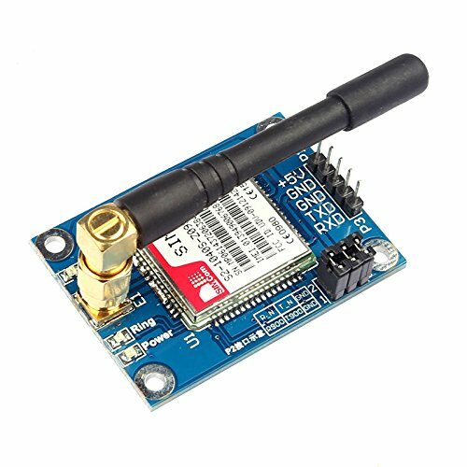

Fig 3.9: GSM Module

The core components of a GSM module typically include:

* **SIM Card Slot:** The GSM module requires a SIM (Subscriber Identity Module) card for network authentication. The SIM card stores subscriber information, such as the phone number and authentication keys, enabling access to the cellular network.
* **Antenna:** An antenna is used for transmitting and receiving radio signals to and from the cellular network. It ensures reliable communication by providing sufficient signal strength and coverage.
* **Microcontroller Interface:** The GSM module is interfaced with a microcontroller or embedded system, allowing communication and control of the module's functionalities. Common interfaces include UART (Universal Asynchronous Receiver-Transmitter) or SPI (Serial Peripheral Interface).
* **Power Supply:** The GSM module requires a stable power supply to operate effectively. It may support a wide range of input voltages and often includes power management features to optimize energy consumption.
* **Communication Protocols:** The GSM module supports various communication protocols, including AT commands, TCP/IP, and HTTP, to facilitate data transfer and network communication.
* **Additional Features:** Depending on the specific model and manufacturer, GSM modules may include additional features such as built-in GPS (Global Positioning System), onboard memory for data storage, and support for additional communication interfaces like Bluetooth or Wi-Fi.

In terms of functionality, GSM modules offer several capabilities:

* **Voice Communication:** Some GSM modules support voice calls in addition to SMS and data communication. This feature enables two-way audio communication between devices or with a designated phone number.
* **SMS Messaging:** The primary function of a GSM module is to send and receive SMS messages. It allows devices to transmit important alerts, notifications, or commands over the cellular network.
* **Data Transfer:** GSM modules with GPRS capabilities enable data transfer over the cellular network, providing Internet connectivity to connected devices. This feature is commonly used in IoT (Internet of Things) applications for remote monitoring and control.
* **Remote Control:** GSM modules can be controlled remotely using SMS commands or data packets sent over the network. This allows for remote configuration, firmware updates, and troubleshooting of connected devices.
* **Location Tracking:** GSM modules with built-in GPS functionality can provide real-time location tracking and geolocation services. This feature is valuable in applications such as asset tracking, vehicle monitoring, and fleet management.

Overall, GSM modules play a crucial role in enabling remote communication and control in various applications, including security systems, industrial automation, vehicle tracking, and IoT devices. Their versatility, reliability, and widespread network coverage make them indispensable components in modern communication systems.